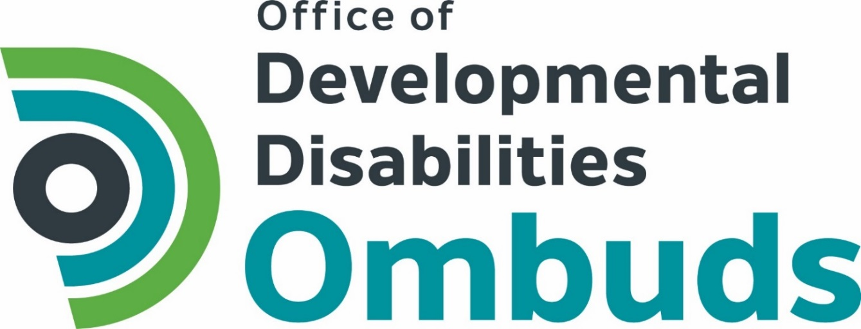

Annual Report 2017
Office of Developmental Disabilities Ombuds

"The legislature finds and declares that the prevalence of the abuse and neglect of individuals with developmental disabilities has become an issue that negatively affects the health and well-being of such individuals.” SB 6564 (2016)

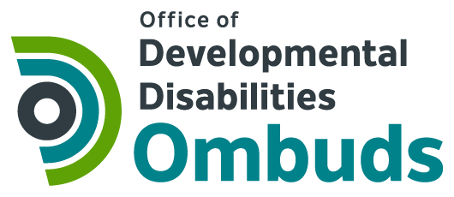

Members of the Legislature November 1, 2017
Governor Jay Inslee
Cheryl Strange, Department of Social and Health Services
Evelyn Perez, Developmental Disabilities Administration

The Office of Developmental Disabilities Ombuds has just begun its work. The legislature created the DD Ombuds program in response to abusive and neglectful conditions for people with developmental disabilities. They envisioned a program akin to the Long-Term Care Ombuds, where advocates go to meet people where they live, provide rights education, and listen to and resolve complaints. That is where we began. In a very short amount of time, DD Ombuds staff visited 37 residences or programs where people with developmental disabilities receive supports and services.

We visited people who received different types and levels of supports and services. We talked with people about our services, gave out written materials, made observations, and listened. We recognize it will take time for people to get to know us, know what we do, and trust us with their concerns. Some people did come forward with concerns and we were able to assist them and resolve issues. The majority of the support staff we spoke to welcomed our advocacy efforts. We will refine our outreach materials and methods of communicating who we are and what we do as we learn what is effective in reaching people, especially people who are survivors of abuse or neglect.

Our duties also include systemic policy work. As we collect more information, we will analyze the data, report on what we found, and make recommendations to the state and the legislature for improvements. Look for an issue-specific report in the spring and a full-year Annual report next September.

We are building our infrastructure with an eye to the future. We intend to fulfil the vision of the legislature to have staff and a robust cadre of volunteers to assist people with developmental disabilities, no matter where they live, to resolve their complaints and address abuse and neglect.

DD Ombuds offices are located in Olympia, Seattle and Spokane.

Thank you for this opportunity to serve and empower people with developmental disabilities.
Betty Schwieterman
State DD Ombuds

Introduction

In 2016, the Washington State Legislature declared, “the prevalence of the abuse and neglect of individuals with developmental disabilities has become an issue that negatively affects the health and well-being of such individuals.” The legislature created an independent Office of Developmental Disabilities Ombuds (DD Ombuds) to monitor and report on services to persons with developmental disabilities.

Background

The Washington State Department of Commerce awarded the non-profit Disability Rights Washington through competitive bid the contract to administer the DD Ombuds program. Disability Rights Washington created a separate program to fulfill the contract. The DD Ombuds contract began on May 25, 2017.

Scope of Annual Report

This report covers the time period between the award date, May 25, 2017 and the end of the state fiscal year, June 30, 2017.

DD Ombuds Program Approach

The legislature considered a proactive approach to DD Ombuds services. They recognized that some people with developmental disabilities are isolated and do not have the resources to reach out for assistance. Therefore, the DD Ombuds' approach is to provide services and take complaints in person as much as possible. The DD Ombuds visits people where they are or where they receive their services to provide information, listen to their concerns, and help resolve complaints.

The DD Ombuds provides information on rights and responsibilities through presentations, trainings, community events, social media and website platforms. The DD Ombuds and people with developmental disabilities develop the publications, videos and website content.

The DD Ombuds will also take complaints by phone and through a website complaint form, but recognizes that many people with developmental disabilities do not have access to the phone or internet.

The DD Ombuds will convene an advisory stakeholder committee, comprised in majority of people with developmental disabilities. The committee will meet in person to advise the DD Ombuds on priority setting, organizational structure and program expansion based on the Long-Term Care Ombuds model.

Powers and duties

The DD Ombuds delivers person-centered, complaint-based Ombuds services. An Ombuds helps people understand their rights and responsibilities and helps people solve their complaints about their services. The DD Ombuds monitors services and reports concerns to the state and the legislature. The DD Ombuds has the powers and duties to provide the following services.

- Provide information on rights and responsibilities
- Investigate complaints
- Resolve issues at the lowest level possible through individual complaint resolution
- Monitor service delivery and review state institutions, state-licensed facilities, and residences
- Protect confidentiality
- Report on services to people with developmental disabilities
- Publish reports on systemic issues to the legislature
- Make recommendations for changes in policy and procedures
- Develop and recommend a plan for growth to expand the program based on Long-term Care Ombuds model to include regional Ombuds, paid staff and a significant volunteer force

Activities of the DD Ombuds May 25 through June 30, 2017

Promotion and Awareness of DD Ombuds

Community stakeholder meeting
Community stakeholder meetings were held in June 2017 in Sequim, Ellensburg, Wenatchee, Kent, Spokane, Aberdeen and Vancouver.

Each meeting included a presentation about the DD Ombuds and asked participants for input on priority issues. Five more community stakeholder meeting are planned for next quarter. Community input from all 12 meetings will be summarized and used to help the DD Ombuds set priorities.

Distribution of information on Rights and Responsibilities

Material development
DD Ombuds staff created two informational handouts: “What is the DD Ombuds,” and “Know Your Rights.”

Resource table at events
The DD Ombuds staffed a resource table at the Community Summit in Wenatchee on June 13 and 14, 2017. The Summit is an annual conference for those involved in creating inclusive communities sponsored by the Developmental Disabilities Administration. The DD Ombuds distributed materials about the program and a handout called “Know Your Rights.”

Website
DD Ombuds full website will launch in Fall 2017. The website will include information, resources, and an on-line complaint form. The Office of DD Ombuds is working with a website developer with expertise in creating fully accessible websites. Website users will be able to employ a read aloud screen reader feature that is built into the website.

Monitoring and review of facilities, residences and programs

The DD Ombuds staff visited 37 facilities, residences and programs in June 2017. The purposes of the visits were to introduce the DD Ombuds program to the residents, staff and administration, meet people who live in a variety of settings across the state, learn about the issues of importance to the residents, take complaints, and monitor conditions. Each residence received DD Ombuds program and “Know Your Rights” information.

State Supported Living Residences
DD Ombuds staff visited people receiving State operated Supported Living services. These homes are located in neighborhoods around the state. Typically two to four people live in a home. State employees provide support services and instruction to the residents with developmental disabilities. Individuals pay their own rent, food, and other personal expenses. The DD Ombuds visited 22 homes where State Supported Living services are provided.
Eight residences in Yakima County
Nine residences in King County
Five residences in Spokane County

Private Intermediate Care Facilities
Seven privately-run residences provide supports to individuals who are assessed to need Intermediate Care Facility (ICF) level of care. ICF level of care requires continuous active treatment to assist the individuals with developmental disabilities to become as independent as possible. The DD Ombuds visited all seven of the private ICFs in the state.
One residence in Pierce County
Six residences in in King County

State Residential Habilitation Center - Intermediate Care Facilities (ICF)
Washington State operates ICFs in three locations. These ICFs have residences and Adult Training programs. The DD Ombuds visited six programs at the state operated ICFs.
Rainier PAT A
Rainier PAT C
Lakeland ICF
Lakeland Adult Training Program
Fircrest Adult training Program

State Residential Habilitation Center - Nursing Homes
Washington State operates three nursing homes for individuals with developmental disabilities. The DD Ombuds visited portions of all three of the nursing home programs.
Yakima Valley
Lakeland
Fircrest

Complaints

The DD Ombuds focused its resources on on-site visits. The DD Ombuds program is new, therefore many people had not yet heard about the program or what the DD Ombuds does. DD Ombuds staff spent time talking with residents and staff to inform them about the program and to ask if they had any concerns or complaints. The DD Ombuds assists people with developmental disabilities to resolve complaints at the lowest level possible.

Number of complaints or concerns received 23
Number resolved 8
Number pending 15

Areas of complaint included: residence conditions, access barriers, safety, odors, access to community activities, access to employment, staffing level, abuse, and lack of guardian at planning meeting. The DD Ombuds is designing a confidential data collection system to track complaints based on the types of complaints received.

Priority Setting

The DD Ombuds is collecting information at community stakeholder meetings, from an online survey and in-person presentations, about what is working and not working in the service system for people with developmental disabilities. This information will help the DD Ombuds set priorities.

DD Ombuds Advisory Committee

DD Ombuds staff began recruiting people for the DD Ombuds Advisory Committee. The Committee membership will be super-majority people with developmental disability, have representation of people who live in different types of residences and reflect the diverse communities of Washington State. There will be at least two members from each DSHS region to ensure geographical diversity. The Committee will meet quarterly to advise and evaluate the work of the DD Ombuds.

Liaison with Developmental Disabilities Administration (DDA)

The Office of DD Ombuds began discussions with DDA regarding DD Ombuds duties, authority and access to information in possession of DDA. DDA will name a liaison to the Office of DD Ombuds.

Conclusion

The Office of Developmental Disabilities Ombuds is in operation to serve people with developmental disabilities who receive services from Washington State. The DD Ombuds delivers person-centered, complaint-based Ombuds services. The DD Ombuds helps people understand their rights and responsibilities and helps people solve their complaints about their services. DD Ombuds services are delivered in-person to people who may not have a way to contact an Ombuds. The DD Ombuds monitors services, reports concerns and makes recommendations to the state and the legislature.

This report covers very initial work of the DD Ombuds program during the last month of the 2016-2017 state fiscal year. Future DD Ombuds Annual Reports will be published by September 1 each year. Annual Reports will include DD Ombuds priorities, goals, data on complaints, monitoring, facility review and recommendations for policy and procedure change.

Questions or comments about this report can be sent to:
Office of Developmental Disabilities Ombuds
315 5th Ave Suite 850
Seattle, WA 98104
info@ddombuds.org

To learn more about the DD Ombuds visit: www.ddombuds.org

